P1-O5 Livelihoods & Social Cohesion
Annual Report to Output Board 2014
February 2015

- OVERVIEW
The ‘Improved Livelihoods and Social Cohesion’ Output (Output 5) is situated under the Local Governance Pillar (Pillar 1) of the UNDP Country Programme Document (CPD 2013-2015). The Output targets ceasefire and high-poverty areas in Rakhine, Kachin, Kayah, Kayin, Shan, Chin and Mon; uses livelihoods as a tool to improve community social cohesion; supports capacities for peacebuilding of government and civil society partners; and facilitates early recovery coordination in Yangon, Rakhine and Kachin. Its output and sub-outputs are as follows:

Output 5 is directly implemented (DIM) by UNDP through a team of UNDP programme, technical and operation staff both in Yangon and in the relevant states. At the national/union level, it works in close consultation with the Progress of Border Affairs and National Races Development Department (NaTaLa) of the Ministry of Border Affairs (MoBA), other relevant line ministries, other United Nations (UN) agencies and donors, under the overall direction of its Output Board. At the state level, the Output collaborates with state and union government institutions, relevant technical departments, other UN agencies, international and national non-governmental organizations (I/N-NGOs), Community Based Organizations (CBOs) and members of the community. To-date, with respect to its village-based activities, Output 5 is working in 313 villages in the 07 above-mentioned states.

This report presents the status of project implementation and summarizes cumulative results for the period January to December 2014, challenges, best practices and lessons learned, as well as relevant financial information.

- CUMULATIVE RESULTS (January to December 2014)
5.1 Social protection (SP) mechanisms in place for poor households at community level
- Under the Output, UNDP completed livelihood and social cohesion assessments and village planning exercises (including poverty score-cards) in 313 villages, to establish baseline information and identify village-level dynamics, needs and priorities.
- In partnership with 33 NGO implementing partners, UNDP has provided social protection assistance (through 194 rice banks) in Shan, Kayah, Kayin, Mon, Chin reaching 89,847 persons (18,260 HHs), of which 46,364 (52%) are women. The rice-banks are helping to reduce food security among poor households, particularly during the rainy season and ahead of cultivation season.
Table a. # of HHs and persons benefitting from rice-banks
State | HH | Male | Female | Total
Kayah | 3657 | 6681 | 6953 | 13,634
Kayin | 2894 | 8155 | 8196 | 16351
Shan | 3585 | 9557 | 9347 | 18904
Mon | 5511 | 11625 | 14209 | 25834
Chin | 2613 | 7465 | 7659 | 15124
Total | 18,260 | 43,483 | 46,364 | 89,847

5.2 Target communities have increased capacities and opportunities for social cohesion and livelihoods
- UNDP set-up village-based CBOs in all target locations, to facilitate project implementation. Out of 1311 village-based CBO members, 466 (35.5%) were women.
- In partnership with NGO implementing partners, UNDP provided capital assistance (cash grants) for agricultural, fisheries, livestock and small and medium enterprises (SME), reaching 93,665 persons (17,406 HHs) of which 46,612 (49.9%) were women. This assistance is providing primary or supplementary income generation opportunities to vulnerable HHs and thereby helping to reduce socio-economic disparities as a way of strengthening social cohesion at the local level.
- 96.8% of those receiving capital assistance for agriculture, livestock and fisheries report an increase in income-generation six months following the receipt of support; while 91.7% of those receiving capital assistance for small and micro enterprises report sustaining their business six months following the receipt of support.
Table b. # of HHs and persons benefitting from livelihood assistance
State | HH | Male | Female | Total
Kachin | 3370 | 10905 | 11417 | 22322
Kayah | 2651 | 7553 | 7578 | 15131
Kayin | 2400 | 8504 | 8939 | 17443
Shan | 2943 | 8177 | 7995 | 16172
Rakhine | 3675 | 9517 | 9829 | 19032
Chin | 2447 | 2603 | 1044 | 3647
Total | 17486 | 47259 | 46802 | 93747

- Under the Output, 316 persons have received community extension training in agriculture and livestock enabling them to provide community extension services to their communities. These persons, majority of whom are youth, now work voluntarily offering their technical advice and services to the village community, as a strategy for strengthening inter-community relations, particularly between young and old persons.

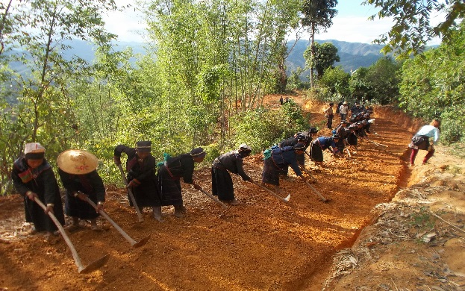
In partnership with ACTED (Kachin), International Rescue Committee (IRC) (Kayah and Chin) and Professional Research Consultancy (PRC) (Shan and Kayah), UNDP constructed 431 units of infrastructure, providing access to 214,393 persons (of whom 107,501 are women). Up to 50,111 (of whom 14,590 were women) benefitted from related cash-for-work schemes. Additionally, community members were trained on infrastructure repair and maintenance, as a strategy to both increase their involvement and the durability of the investment. Physical infrastructure improvements have linked villages to livelihood mainstays such as farms and markets and public and social services such as hospitals, schools and government offices. These also helped link otherwise remote and isolated villages to each other. Cash for work schemes and exchange/study visits have helped strengthen interaction and networking between different communities.
 |  |  | Table c. # of Infrastructure Units Constructed
Types of infrastructure projects |  |  |  | Shan | Kayah | Kayin | Chin | Kachin | Rakhine | # of units
Bridges |  |  |  | 5 | 8 | 30 | 9 | 4 | 3 | 59
Roads |  |  |  | 32 | 42 | 31 | 55 | 38 | 7 | 205
Culvert |  |  |  | 21 | 39 | 13 | 0 | 24 | 0 | 97
Community Hall |  |  |  | 0 | 0 | 0 | 0 | 2 | 0 | 2
Water System |  |  |  | 22 | 0 | 0 | 12 | 12 | 0 | 46
School |  |  |  | 0 | 0 | 0 | 0 | 2 | 0 | 2
School Fence |  |  |  | 0 | 0 | 0 | 0 | 2 | 0 | 2
Village Market |  |  |  | 0 | 0 | 1 | 0 | 0 | 1 | 2
Dyke Raising |  |  |  | 0 | 0 | 0 | 0 | 0 | 1 | 1
Water Pond |  |  |  | 0 | 0 | 0 | 0 | 0 | 10 | 10
Shore Retaining wall |  |  |  | 0 | 0 | 0 | 0 | 0 | 1 | 1
Jetty |  |  |  | 0 | 0 | 0 | 0 | 0 | 1 | 1
Embankment |  |  |  | 0 | 0 | 0 | 0 | 0 | 1 | 1
Health Center |  |  |  | 0 | 0 | 0 | 0 | 0 | 2 | 2
Total |  |  |  | 80 | 89 | 75 | 76 | 84 | 27 | 431

Table d. # of persons benefitting from Infrastructure and cash for work schemes
State | # of persons accessing/using | # of persons benefiting from cash-for-work
Kayah | 20480 | 4138
Kayin | 40234 | 4868
Shan | 19,502 | 30112
Kachin | 34,465 | 2125
Chin | 15774 | 2324
Rakhine | 82,295 | 6544
Total | 212,750 | 50,111

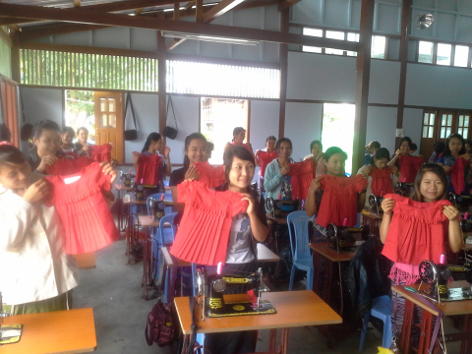
In partnership with the Small-scale Industries Department (SSID) of the Ministry of Cooperatives, UNDP provided vocational mobile training clinics on motorcycle repairing, carpentry, sewing, food processing and handicraft-making, reaching up to 621 people of whom 49% are women in 179 villages in 14 townships in Kachin, Kayah, Kayin and Shan States. As part of the training clinics, participants are also trained to develop business plans and provided with start-up capital or tools for setting-up small enterprises based on the merits of their business plans.
 | Table e. # of persons benefiting from vocational training
Types of vocational training |  | Shan | Kayah | Kayin | Kachin | Total
Sewing |  | 30 | 60 |  | 60 | 150
Food Processing |  | 30 |  | 90 | 57 | 177
Motorcycle Repair |  | 30 | 60 | 30 | 58 | 178
Handicrafts |  |  |  | 56 |  | 56
Carpentry |  |  | 60 |  |  | 60
Total |  | 90 | 180 | 176 | 175 | 621

- In May 2014, UNDP was requested by the Rakhine State Government (RSG) and Emergency Coordination Committee (ECC) to support development activities in one additional village and to construct the Ye Chan Pyin Bridge, both in Sittwe Township, Rakhine State. Under the Output, livelihoods and social cohesion activities were initiated achieving the following results: establishment of a food bank benefitting 87 HHs of which 206 are female beneficiaries (52%); provision of capital assistance for agriculture, livestock, fisheries and MSE reaching 82 households; provision of equipment and training for a prawn preservation, processing and paste-making facility benefitting 104 persons of whom 67 are women; provision of training to CBOs reaching 20 persons. The Output commenced construction activities on Ye Chan Pyin Bridge in Rakhine State which once completed will be accessed by 3220 households.
- As a result of UNDP’s activities at the village level, there is a 43.9% increase in the number of persons reporting having more than five occasions for interacting with a member of a different village or community and 77.7% of persons reporting perceptions of increased unity of people from different communities.

  - National and local institutions and actors have increased capacities for conflict sensitivity, social cohesion and peace-building

- In February 2014, UNDP facilitated a study visit to Indonesia for Union and Rakhine State Government representatives to gain first-hand knowledge on social cohesion experiences, models and lessons. During their visit, the delegation, which was led by HE Major General Maung Muang Ohn, former Deputy Minister for Border Affairs (now Chief Minister for Rakhine State) and included 03 Ministers from Rakhine State Government, had discussions with a wide range of Indonesian stakeholders from government and civil society, both at the national and provincial level, and exchanged ideas and information on many issues relating to social cohesion and peacebuilding. Key issues of value and interest included: social cohesion and peacebuilding policies; conflict and violence monitoring; participation of civil society in social cohesion and peacebuilding, especially women’s organizations; and the use of media and technology for social cohesion and peacebuilding.
- UNDP developed and rolled-out a 3-day social cohesion training module for implementing partners and staff. The training reached 115 representatives from partner organizations (of whom 65%) were women and 30 staff. Following, UNDP also broadened its outreach to local government, Non-State Actors and Civil Society Organizations, through 3-day social cohesion training workshop in Kachin and Shan.
- Also under the Output, UNDP initiated a capacity-development programme aimed at strengthening dialogue platforms and capacities in Myanmar. To-date, capacity development activities have outreached 110 senior officials from the Ministry of Border Affairs, the General Administration Department (GAD) and the Myanmar Police Force (MPF) of the Ministry of Home Affairs (MoHA) at union level, and also in Shan and Mandalay. Work at state level also outreached Civil Society Organizations (CSOs).
- The Output also contributed to increasing women’s participation in peacebuilding, by supporting Myanmar’s first nomination of 2 women peace-builders and 1 women’s peacebuilding organization for the 2014 N-Peace Awards, which they won in their respective categories. Also as part of NPEACE, the programme supported the participation of 1 female Member of Parliament (MP) and 05 women’s organizations at an international training workshop on Women, Peace and Security issues. In December 2014, UNDP conducted an in-country assessment on women’s leadership and participation in social cohesion and peacebuilding. The assessment included meetings with stakeholders in government and civil society, both at Union level, and also in Mon and Kayin states. The assessment will feed into a broader programme of support for women’s leadership in peacebuilding through South-South and Triangular Cooperation between Indonesia and Myanmar (WLP-SSTC) in 2015.
5.4 Strengthened early recovery (ER) processes in place in target locations
- UNDP continued to provide regular dialogue platform for early recovery for a wide range of interested ministries/ political actors and early recovery agencies in Rakhine Kachin and Yangon. As a result of UNDP’s ER coordination capacity, both in Yangon and in Rakhine and Kachin, there is increasing recognition of ER as a cross cutting element within humanitarian operations.
- Under the Output, UNDP led or participated in several field assessments, including the Inter-Agency assessment on Monitoring and Sustaining Durable Solutions in Kachin State and the Pa La Na Relocation Assessment. UNDP had regular engagement with authorities on recovery and reintegration of IDPs in Kachin State. A draft Terms of Reference for a technical working group on Durable solutions has been prepared, with active participation of the government, to coordinate all support to the government on durable solutions. In coordination with state authorities, local NGOs, INGOs and UN agencies on Durable Solutions, draft Durable Solutions Strategy for Kachin and Northern Shan States have been developed.
- UNDP has supported the drafting of the Humanitarian Response Plan 2015 by providing inputs for Livelihoods and ER mainstreaming.

- CUMULATIVE RESULTS AGAINST INDICATORS (January to December 2014)
CPAP Outcome level | Output Indicators | Targets | Progress Towards Targets (2014)
Output 5 :  Target communities and institutions have increased capacities for social cohesion, sustainable livelihoods, and improved opportunities for peace | Indicator 01  - Increase in % of women representatives in community-led governance structures in target locations  Baseline: 25% | Target (cumulative)  40%  Target (2014)  30% | - Achieved.  - 35.5% (466 of 1311) of village CBO members are women
 | Indicator 02  - # of persons targeted for livelihood assistance reporting increase income-levels in target locations 06 months after having received support (disaggregated by gender)  Baseline: 0 | Target (cumulative)  70%  Target (2014)  70% | - Achieved.  - 96.8% reporting increased-income  - Male: 79.2%; Female: 95.5%
 | Indicator 03  - # of persons targeted for micro-enterprise support reporting sustaining their enterprises 6 months after having received support (disaggregated by gender)  Baseline: 0 | Target (cumulative)  80%  Target (2014)  70% | - Achieved.  - 91.7% reporting sustaining businesses at least 6 months after having received support  - Male: 91.7 % ; Female : 91.7%
 | Indicator 04  - # of persons using/accessing constructed/rehabilitated infrastructure units  Baseline: 0 | Target (cumulative)  300,000  Target (2014)  200,000 | - Achieved.  - 212,750 using/accessing constructed or rehabilitated infrastructure units  - Male : 105,249; Female:107,501
 | Indicator 05  - % increase in households reporting ‘more than 5’ occasions for interacting with a member from another village/ethnicity in past 06 months as a result of UNDP's interventions in target locations Baseline: 31% | Target (cumulative)  50% increase  Target (2014)  40% increase | - Achieved.  - 43.9% increase in number of persons reporting ‘more than 5 occasions for interaction as at reporting date of 15 November 2014
 | Indicator 06  - % decrease in # of persons reporting feeling ‘unsafe’ to move around and travel in target locations in Rakhine and Kachin (disaggregated by gender, age and ethnicity)  Baseline: 95% | Target (cumulative)  75% (20% decrease)  Target (2014)  65% (10% decrease) | - Data unavailable at present
 | Indicator 07  - % of persons targeted reporting perceptions of increased unity between people from communities in target locations  Baseline: 0 | Target (cumulative)  50%  Target (2014  40% | - Achieved.  - 77.7% of persons targeted reporting perceptions of increased unity in target locations
 | Indicator 08  - # of civil society peace building activities supported by UNDP | Target (cumulative)  30  Target (2014)  15 | - Partially achieved.  - 5 women peace-builders supported to participate in NPEACE awards and training workshop; 2 social cohesion competencies workshops rolled-out in Shan and Kachin with participation of local government, NSAs and CSOs; 5 social cohesion training workshops rolled-out for 115 members of non-governmental organizations (implementing partners); 5 workshops on dialogue skills and capacities rolled-out for government and CSO partners in Yangon, Nay Pyi Taw, Shan, and Mandalay
 | Indicator 09  - # ER strategies developed and implemented | Target (2014):  ER strategy developed and incorporated in Humanitarian Response Plan 2014  Conflict sensitivity trainings rolled out within government and humanitarian partners | - Partially achieved.  - 7 conflict sensitivity trainings rolled out in Rakhine, Kachin and Nay Pyi Taw reaching 120 participants from government and humanitarian partners
 | Indicator 10  Early Recovery principles integrated in humanitarian sector/ cluster response plans | Target (2014):  ER mainstreamed into humanitarian response | - Achieved  - Humanitarian response plan 2014 consists of concrete ER strategic approach; other humanitarian clusters include ER outcomes as a mainstreaming elements  - ER Network established through an HCT decision

5. CHALLENGES AND LESSONS LEARNT
- In Rakhine, UNDP’s efforts to improve social cohesion between Muslim and Rakhine communities were demonstrating initial results. Unfortunately however, due to the March unrest and attacks on UN/INGO premises, UNDP was compelled to suspend project implementation for several months. Despite the sensitive context, the work of rebuilding relations and trust remains important.
- In 2014, UNDP engaged with 35 implementing partners (IPs) for its village-based livelihood and social cohesion activities (2 international NGOs, and 33 NGOs). UNDP was not able to dedicate so much time as needed for strengthening the capacities of its IPs, given pressures for programme and financial delivery over a very short time-frame. While a majority of the IPs, already well-experienced, delivered strong results, some IPs did not meet the desired objectives. It is important to ensure that IPs are supported with training and on-the-job accompaniment throughout the partnership.
- A framework funding arrangement has helped the ‘Improved Livelihoods and Social Cohesion’ Output (Output 5), to be flexible and respond to evolving contexts and support evidence-based requests. For example, in 2014, UNDP was able to respond positively to requests from union and state government in addressing development and early recovery needs both in Rakhine and Kachin States.

6. FUTURE DIRECTIONS (2015)

- In partnership with Mercy Corps, UNDP will launch a pilot project in Shan, Kayin and Mon states for introducing affordable livelihood technologies to poor and vulnerable communities. Adopting market-based approaches, the intervention will help local entrepreneurs (mostly women and youth) to retail technologies such as fuel-efficient cook-stoves, portable solar lights and solar chargers to rural communities.
- In Rakhine, UNDP will completed the construction of Ye Chan Pyin Bridge in Sittwe township and in Kachin, UNDP will support the sustainable return of IDPs through the provision of livelihoods and social cohesion and infrastructure support in Pa La Na (Myitkyina township).
- In partnership with Search for Common Ground (SFCG), UNDP will develop and roll-out a multi-audience training module on social cohesion trainings to government representatives, civil society organizations (CSOs) and community-based organizations (CBOs) in the 07 states.
- With potential new funding, the Output will continue to support village-based livelihood and social cohesion activities, with a focus on improving value-addition livelihoods, vocational skills and entrepreneurship. This work will continue to aim at improving social cohesion at the local level by reducing socio-economic gaps and increasing dialogue, interaction and trust between different identity-groups.

7. FINANCIAL SUMMARY
In 2014, the Output delivered USD 7,041mil against an annual budget of USD 7.82mil, recording a delivery percentage of 90%.

FINANCIAL SUMMARY - PROGRAMME

DONOR | DURATION | TOTAL ALLOCATION | 2014 Budget | CUMULATIVE DELIVERY  (JAN-DECEMBER 2013-2014) | DELIVERY  (JAN-DEC 2014) | DELIVERY AS % OF 2014 ALLOCATION
GOVT.JAPAN | 2013-2015 | 10,018,894 | 4,853,002 | 8,658,238 | 4,771,956 | 98%
UNDP CORE | 2013-2015 | 1,075,405 | 195,500 | 1,041,621 | 161,256 | 82%
UNDP BCPR | 2013-2015 | 441,829 | 395,562 | 349,539 | 309,539 | 78%
DANIDA | 2014-2015 | 1,210,279 | - | - | - | 0%
TOTAL |  | 12,746,407 | 5,444,064 | 10,049,398 | 5,242,751 | 96%
 |  | 66% | 70% | 78%
FINANCIAL SUMMARY - OPERATIONS
DONOR | DURATION | TOTAL ALLOCATION | 2014 Budget | CUMULATIVE DELIVERY (JAN-DECEMBER 2013-2014) | DELIVERY (JAN-DEC 2014) | DELIVERY AS % OF 2014 ALLOCATION
GOVT. JAPAN | 2013-2015 | 1,516,350 | 672,885 | 1,484,954 | 641,489 | 95%
UNDP | 2013-2015 | 4,053,811 | 1,247,272 | 866,004 | 801,575 | 64%
UNDP BCPR | 2013-2015 | 1,058,171 | 461,655 | 513,690 | 353,907 | 77%
DANIDA | 2014-2015 | 35,681 | 2,510 | 1,626 | 1,626 | 65%
TOTAL |  | 6,664,014 | 2,384,322 | 2,866,274 | 1,798,597 | 75%
34%  FINANCIAL SUMMARY OVERALLL |  |  | 30% | 22%
DONOR | DURATION | TOTAL ALLOCATION | 2014 Budget | CUMULATIVE DELIVERY (JAN 2013-DECEMBER 2014) | DELIVERY (JAN-DEC 2014) | DELIVERY AS % OF 2014 ALLOCATION
GOVT. JAPAN | 2013-2015 | 11,535,244 | 5,525,887 | 10,143,192 | 5,413,445 | 98%
UNDP CORE | 2013-2015 | 5,129,216 | 1,442,772 | 1,907,624 | 962,831 | 67%
UNDP BCPR | 2013-2015 | 1,500,000 | 857,217 | 863,229 | 663,446 | 77%
DANIDA | 2014-2015 | 1,245,960 | 2,510 | 1,626 | 1,626 | 65%
TOTAL |  | 19,410,421 | 7,828,386 | 12,915,672 | 7,041,348 | 90%

Vocational Skills Training Expands Opportunities for Myanmar Youth and Women

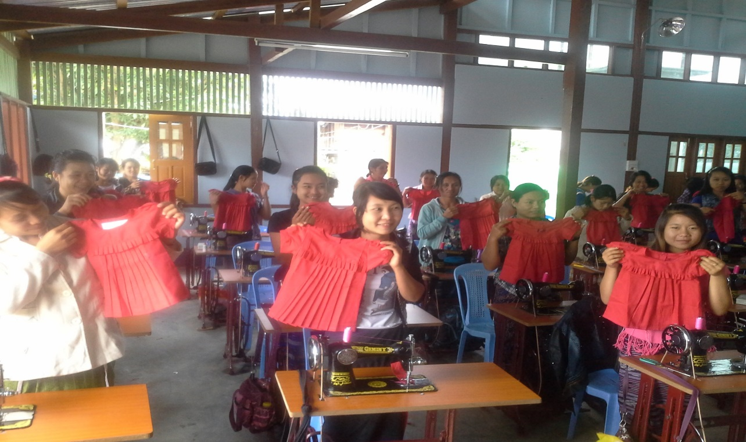
The United Nations Development Programme (UNDP) and the Small Scale Industries Department (SSID) of the Ministry of Cooperatives are partnering to provide vocational and livelihood skills training in Kachin, Kayah, Kayin and Shan, as part of UNDP’s livelihoods and social cohesion programme.
Under this new partnership, vocational trainers attached to SSID are conducting mobile training clinics on motorcycle repairing, carpentry, sewing, food processing and handicraft-making, reaching up to 621 people in 179 villages in 14 townships. As part of the training clinics, participants are also trained to develop business plans and provided with start-up capital or tools for setting-up small enterprises based on the merits of their business plans.
Speaking about the initiative, U Mya Than, Director General of SSID, said “The Small Scale Industries Department is already working with UNDP on upgrading one of the country’s vocational training institutes. We are pleased to continue this partnership to promote vocational skills for small-scale enterprises in the Border States. We started this work by conducting a scoping mission to the townships to identify which skills were most in demand and which enterprises were most suitable based on the availability of raw materials and market potential.”
Speaking at the inauguration of training activities in Kayah in September, U Zaw Min, Chief Minister of Kayin State Government confirmed the potential of this partnership. “This initiaitve brings good business opportunities for rural communities by turning vocational skills into entrepreneurship opportunities.” he said.
This work aims to increase income-generation, entrepreneurship and employment opportunities among vulnerable communities. The mobile clinics are helping people to access training opportunities that are otherwise only available in urban areas. This is especially helping the 312 women trainees, who would otherwise have found it hard to travel and be away from their families.
“I need to go to Hopong Township for tailoring because there is no tailoring shop in my village,”’ says Nant Aye Yee from Htee Ka Too village in Shan state. “I plan to run a tailoring shop in my village as soon as the training is completed. I can earn about 3000 kyats per blouse.” she added.
Daw Daung Naw, from Le Kone village, from Myitkyina Township in Kachin state recently joined the food processing training clinic. “I will start wine making business as soon as the training is completed. In addition, I will conduct a three-day food preservation training for fellow community members who are currently staying in the IDP camp. I would like to be a multiplier”.
The intervention is contributing to the social cohesion objectives of UNDP’s work in this area. People from different communities are finding the training clinics a good opportunity to interact with others from different villages, townships and ethnic groups. Khun Htay Maung of Kyaung Lwae village who joins other young men from Shan for the motorcycle repair training says, “Now, all of us have become friends. I am slowly learning the art of living with others peacefully.”
This work is part of a UNDP programme that covers 313 villages in 24 townships in 07 states in the country. In partnership with over 35 non-governmental organizations, UNDP is supporting the livelihood and social cohesion needs of communities by providing them with social protection assistance; grants for agriculture, livestock and micro-enterprises; vocational training; community mobilization and training; and infrastructure. The work is made possible with funds from Japan, DANIDA and UNDP.

Community Infrastructure Improves Lives
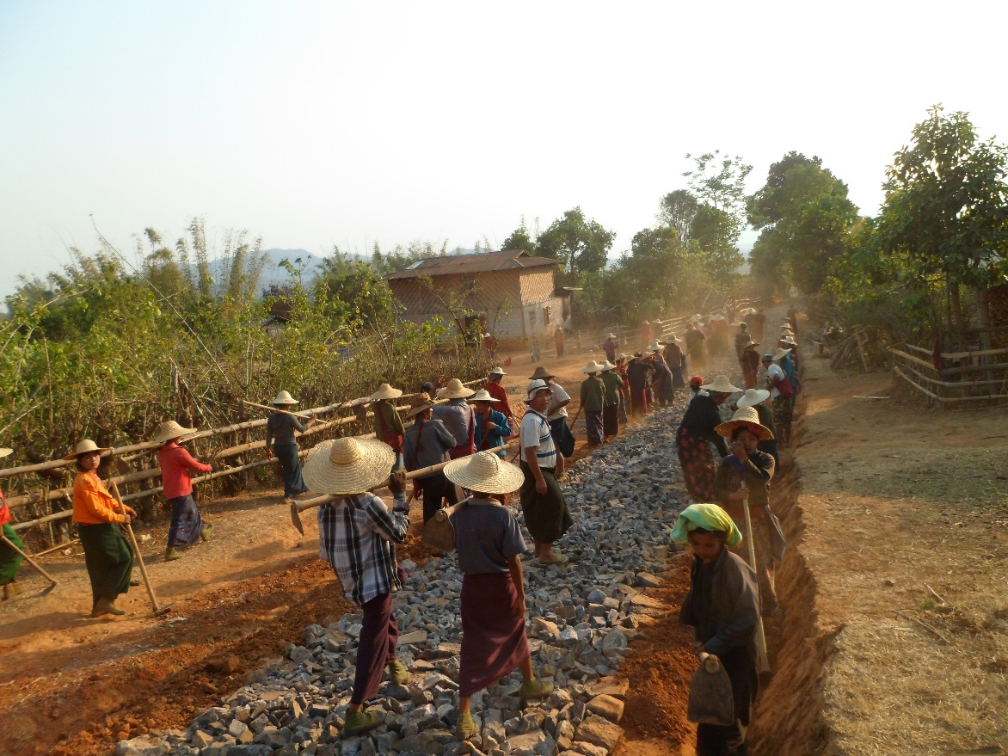
Over two hundred thousand persons living in Rakhine, Kachin, Shan, Kayah, Kayin and Chin are benefitting from access to new roads, bridges, health centres and other community infrastructure this year.
These new infrastructure units were constructed as part of the livelihoods and social cohesion initiative of the United Nations Development Programme (UNDP) and implemented together with the Agency for Technical Cooperation and Development (ACTED), the International Rescue Committee (IRC) and the Professional Research Consultancy (PRC). Through this partnership, UNDP has constructed nearly 431 livelihood and community infrastructure units reaching upto 212,750 men, women and children in Rakhine, Kachin, Shan, Kayah, Kayin and Chin. Construction activities have also provided quick income-generation opportunities for 50,111 men and women through cash-for-work. Village committees are responsible for identifying infrastructure needs, managing funds, planning cash-for-work activities and monitoring implementation. Village members have also been trained in simple repair and maintenance which will help them to upkeep their new facilities.
These facilities are helping conflict-affected and poor villages to access agriculture lands, farms, markets, schools, hospitals and government offices more easily. For example, the construction of a single access road in Northern Kachin gives 220 households in Tat Kone and Lawan Kahtaung villages year-round access to schools and workplaces, where previously the road was unusable during Myanmar’s 5-month long rainy season.
Speaking at the inauguration of a new access road in Kachin, Hon U Kyaw Shwe, Member of the Kachin State Parliament said that improvements to small infrastructure such as those supported by UNDP were very much in line with the government’s own priorities for rural development.
Speaking about the work, ACTED Country Representative Samuel Monet said, “The project has been very successful, not only have beneficiaries earned quick income but they have gained access to new sustainable infrastructures and very importantly, the committees expressed that they are now feeling more confident and have better relationships with local authorities.”
This work is helping strengthen relations among ethnically-diverse and often isolated communities. For example, in Kayah state, people from Demoso and Hrpuso townships participated in inter-village exchange visits to share experiences about community infrastructure. “We learnt that the Demoso villagers planned their cash-for-work schedules more systematically than we did. We need to do that better next time,” said U Jeronimo, of Htitaw Tini Khu village in Hpruso Township during one such visit.

For example, an access road jointly planned and built by Rakhine and Muslim communities of Cheik Taung and San HTo Tan villages in Minbiya Township have helped the two communities to rebuild ties in the aftermath of the 2012 violence. “We are not afraid to come to the main road now,” says a San Hto Tan resident, referring to the access road that now connects the two villages.

This work is part of a UNDP programme that covers 313 villages in 24 townships in 7 states in the country. In partnership with over 35 non-governmental organizations, UNDP is supporting the livelihood and social cohesion needs of these communities by providing them with social protection assistance; grants for agriculture, livestock and micro-enterprises; vocational training; community mobilization and training; and infrastructure. The work is made possible with funds from Japan, DANIDA and UNDP.

As at reporting date of 15 November 2014
Data unavailable for Rakhine at present.

